**Name: كيرلس فوزي شهدي جرجس**

**B.N: 618**

**Date:**

**Topic: programing languages**

**GitHub link:**

**GitHub page :**

**Application brief:**

**Source code:** 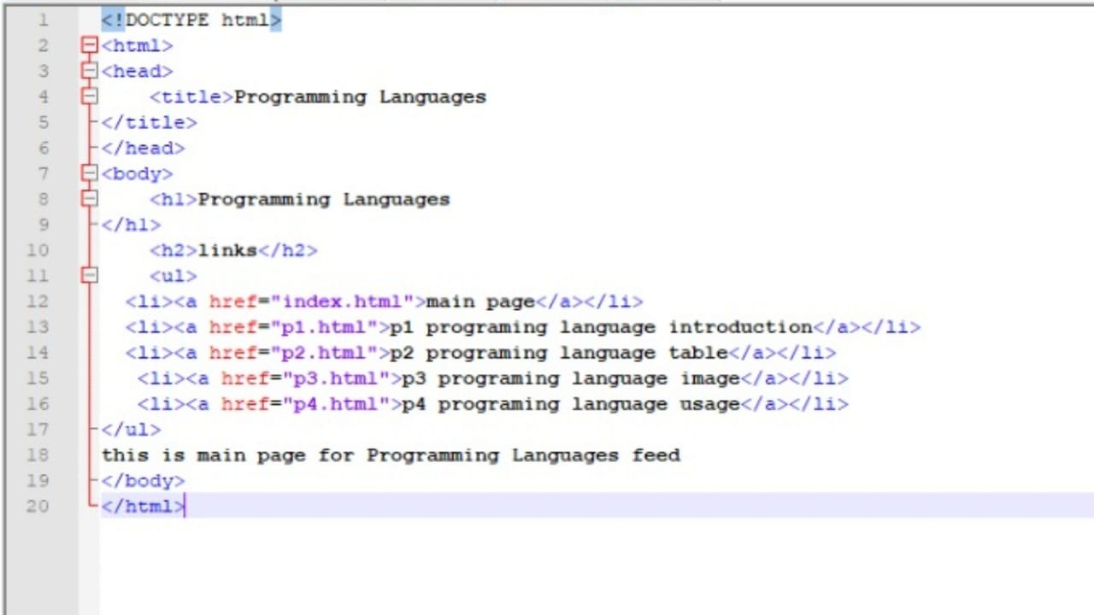

**Screenshots:** 